
Some useful equations for half-lives
The rate of decay of a radioactive source is proportional to the number of radioactive atoms (N) present,
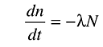
λ is the decay constant, which is the chance that an atom will decay in unit time. It is constant for a given isotope.
The solution of this equation is an exponential one, where N₀ is the initial number of atoms present:
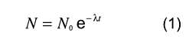
Constant ratio
This equation shows one of the properties of an exponential curve: the constant ratio property.
The ratio of the value N₁ at a time t₁ to the value N₂ at a time t₂ is given by:
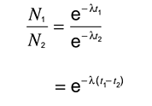
In a fixed time interval, t₂ – t₁ is a constant. Therefore the ratio
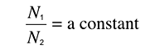
So, in a fixed time interval, the value will drop by a constant ratio, wherever that time interval is measured.
Straight-line log graph
Another test for exponential decay is to plot a log graph, which should be a straight line.
From equation 1:
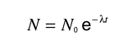
Therefore a graph of lnN against t will be a straight line with a slope of –λ.
Half-life and decay constant
The half-life is related to the decay constant. A higher probability of decaying (bigger λ) will lead to a shorter half-life.
This can be shown mathematically.
After one half life, the number, N, of particles drops to half of N₀ (the starting value). So:
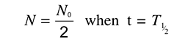
Then, by substituting in equation (1),
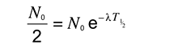
Taking natural logs of both sides gives:
